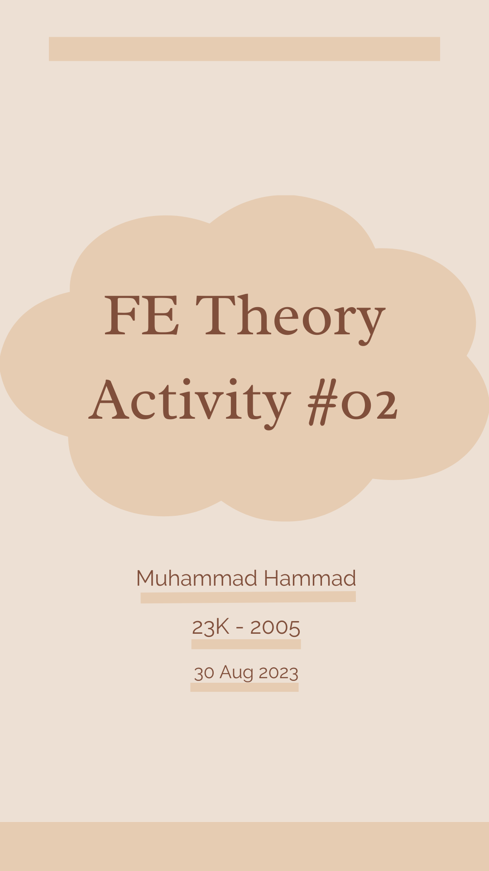

|  |  |  |  |  |
| --- | --- | --- | --- | --- |
| Noun Phrase **◍** | Verb Phrase **◍** | Adjective Phrase **◍** | Adverb Phrase **◍** | Prepositional Phrase **◍** |

#01:   
A young disabled child was skillfully driving the red colored special-person car which his old father gifted him last month on his twentieth birthday.

#02:

The evergreen film of Shahrukh Khan which was shot in Bangkok will be premiered next week after the elections.

#03:

The woman whom we met yesterday in the library is the new Head of Department of Cyber Security.

#04:

The green colored ball which you gave me yesterday after the supper has been lost by me in the bushes.

#05:

I will definitely be back at our new house from the school's farewell party before my father comes home.

#06:

The young talented girl Ayesha from Lahore will be participating in the amazing school event hosted by the board of Education.

#07:

An old feeble man sought help from the young and active children who were playing basketball in tennis jersey wearing a cricket helmet in the newly developed football field.

#08:

Ali is the elder brother of the little girl who was kidnapped yesterday from the famous daycare run by a group of teenagers.

#09:

The black guy who was shot yesterday in the evening was part of a dangerous terrorist organization which operates in South Asia.

#10: India which is a large economic giant was given independence on 15th of August following the independence of our beloved country Pakistan.